Cole Nielsen

LA 1201

Exercise 2

TA: Rachel Kerber

**Introduction:**

My methodology for recording what people were doing and their behaviors at my site (West river flats) was mainly based around the map I created for each observation session. Each map was the same to begin with, having just a basic layout of the paths and features of each and nothing else. During each session I used a coding scheme that I developed on the fly as I saw things happen. The main reason I did this is because I didn’t really know what to expect for behaviors at the site since I saw only a couple of people at the site previously for exercise one and that isn’t enough to accurately base a coding scheme on. How I implemented this coding scheme was that I had open space for map symbols and tally-tables on my map and then I would add things as I saw them and then keep updating them if I saw a behavior happen again. My field notes were taken partially on the map as direct annotations (such as the circles with number, the notes pointing to things with arrows) to clarify things, as well on a separate sheet of paper for more general notes. I was able to integrate recording behaviors using my coding scheme into my field notes by referencing the coded data on my map that represents behaviors I saw in my notes, which makes it easy to go back and review what happened. With my coding scheme, I was able to record whether people were moving about or staying stationary by drawing the path they take if they were moving, or drawing a symbol (seen in the indices) that represents the type of person if they were stationary. My coding scheme shows how fast people are moving by detailing their method of locomotion, such as walking, running or biking.

**Blank Map:**

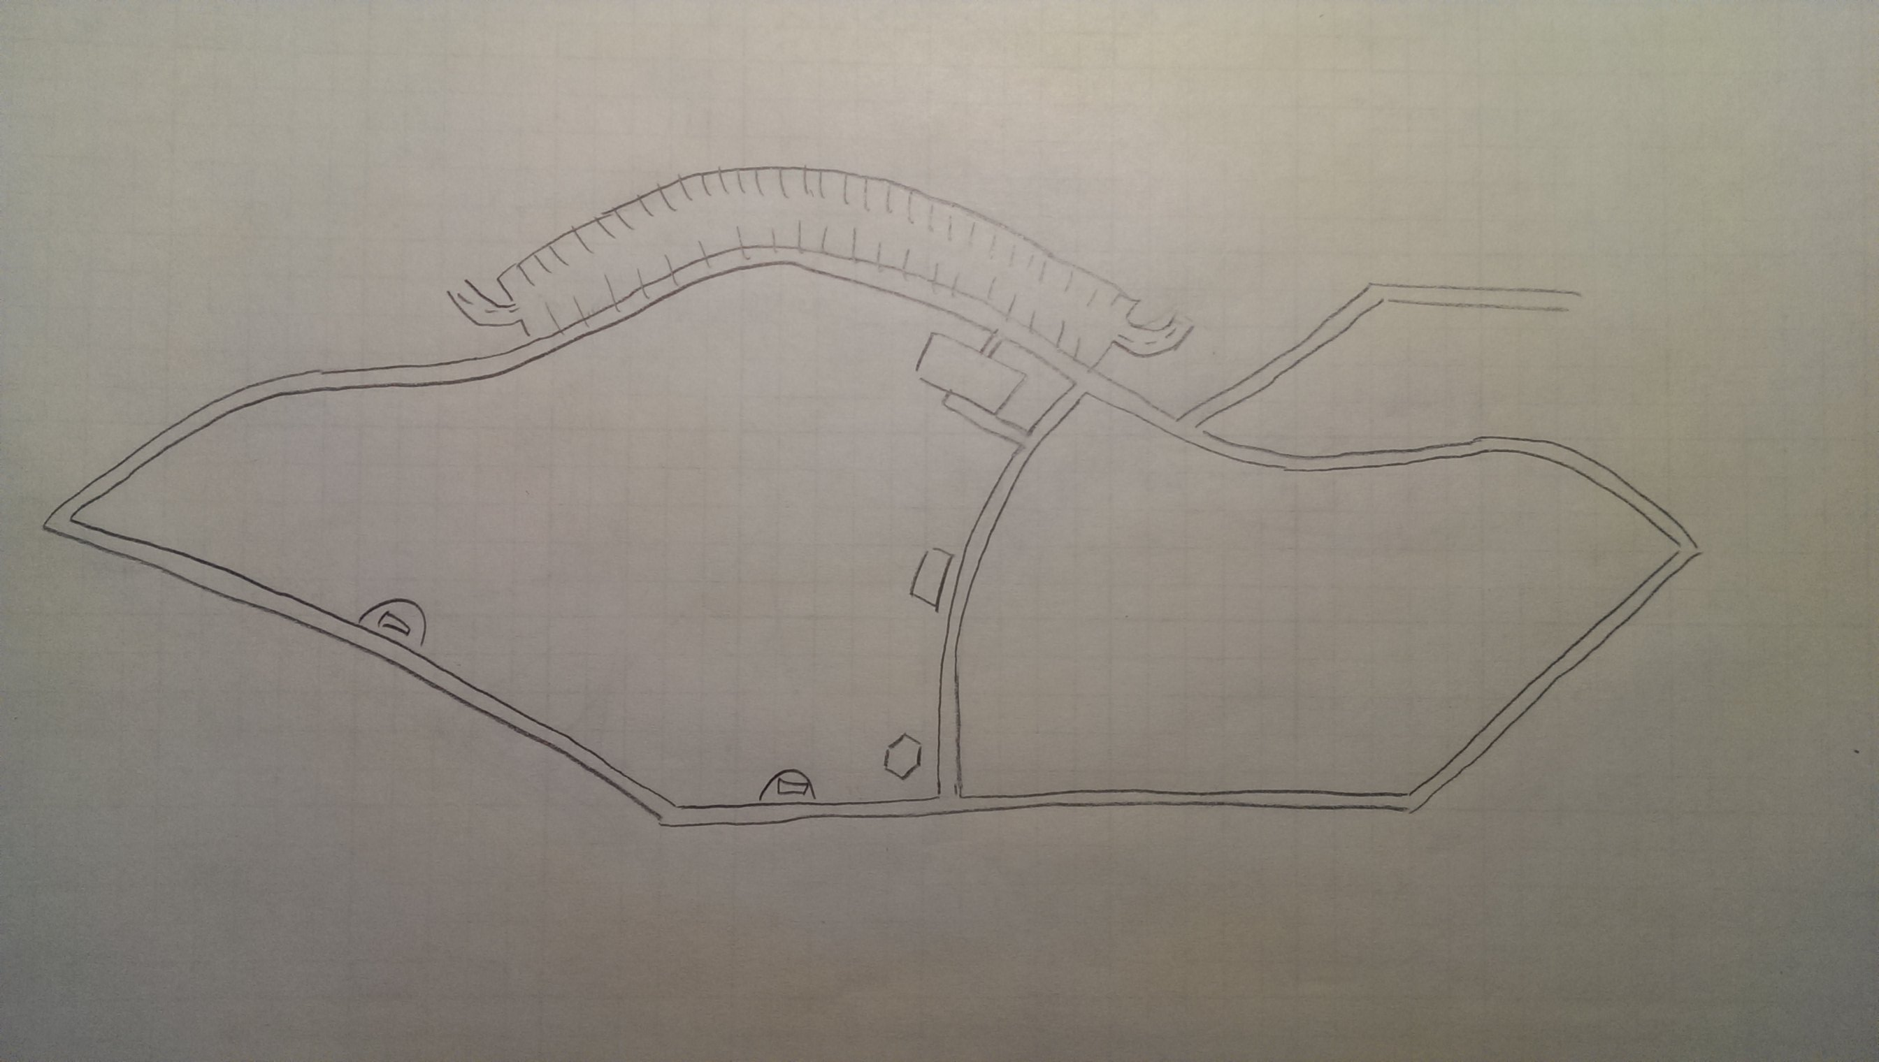

**Observation 1: Behavioral Map**

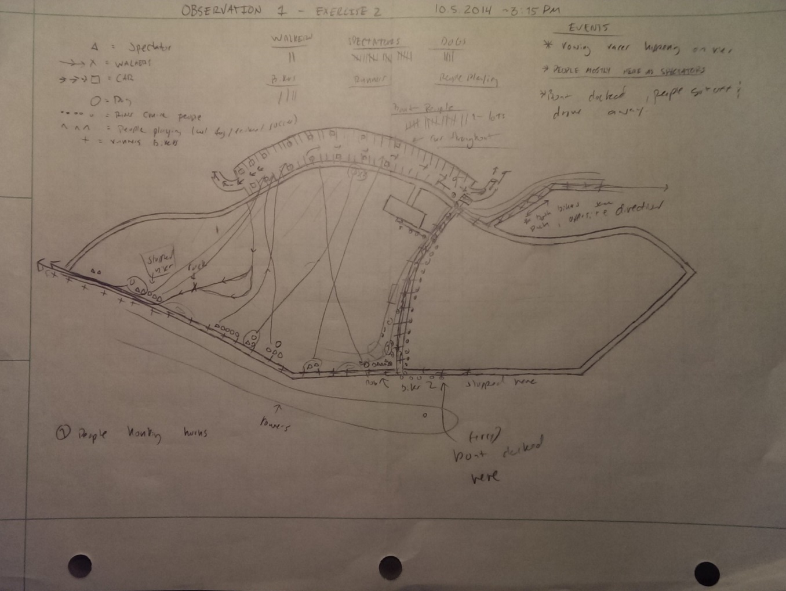

**Observation 1: Notes**

The first thing I noticed upon arriving at the west river flats was that there were a bunch of people (about 16) standing and sitting along the riverfront. I can presume they were watching the rowing races in the river as they were standing there and cheering and honking air horns as the boats passed. After some time another couple came down from the parking lot and then came to the riverfront and started to spectate the race too. About the same time another couple came down from the parking lot, down the grass hill and to the path along the river front, then followed the path and then continued walking along the river front after the side walked ended. I stopped watching them because they left the bounds of my site. Over the next ten minutes several people from each of the groups spectating along the river front walked up the hill to the parking lot and then back down to spectate, presumably after getting things from their car. Also at this time a ferry-type boat began to approach the docks/west river flats from the distance. Waiting for the boat to dock I observed a few more new people. One person came on a bike from the north and then stopped by and started to talk to the people closest to the hexagon on the map (the gazebo thing). Another person on a bike traversed across the park on the paths along the river at about the same time as the previous biker. Finally after about 5 minutes the ferry finally docked. People began to walk around on the deck of the boat. While waiting for them to get off, I noticed that a lot of the people spectating the race had dogs (there were 4 dogs total amongst all the groups). I thought that behavior (bringing dogs) to a park made sense. Finally the boat docked. A lot of people started to pour out of the boat onto the dock and into the river flats. Most of them walked along the path straight to the parking lot, however a younger child ran off the path into the grass and his family followed him, and then went back on path. All together there were 20 or so people who got off the boat (I lost track of the exact number). Everybody I saw who got off the boat left the flats by car.

**Observation 2: Behavioral Map**

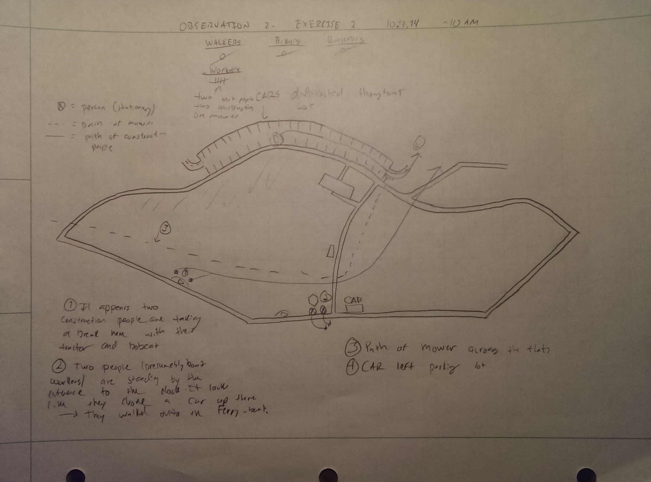

**Observation 2: Notes**

Upon arriving for my second round of observations the park was significantly quieter than in my prior session. That makes sense though because I was there at around 10 AM on a colder weekday morning, so people probably don’t want to be there. My prior session was probably busy because I went there on the weekend (when people are not busy) and there were races and boat tours going on in the river. The other immediate observation I had was that there were two construction worker type people sitting at one of the benches by the river (the circled 1 on the map) with their tractor and bobcat parked nearby. They got in their machinery and left the flats heading north (the path leading from the circle 1 to out of the park) to the road. Also at this time there was a car by the entrance to the boat dock with two people meandering about in the area and on the docks. I presume they were boat workers. They were present there the whole time of my observation. After a while of no new people, a large riding lawnmower came from south of the flats and then proceeded to drive across the flats up into the parking lot and then beyond the scope of my site. For another five minutes there was no change. The last thing I observed was a car that left the parking lot of the flats. After waiting another five minutes of no change, I decided end this observation.

**Difficulties, Challenges and Reflections**

The biggest difficulty I had coming into this exercise (especially in pre-observation work) was trying to come up with a coding scheme before the exercise. This is because I saw next to no one in my first exercise, so that meant I saw essentially no behaviors at the park during it and had little to base my expectations on. I ended up dynamically adding and making my coding scheme as I went during my first observation to deal with that challenge and it worked pretty well. Another difficulty I experienced was that there was a very small amount of activity during my second observation. Because of that I had little data from this session. I also experienced another difficulty which is the types of behaviors that occurred in each session were completely different, so they were hard to compare with each other to establish a strong idea of what goes down on the flats.

A few remarks I have regarding my observations at the park are that there seems to be little recreational activities that occur at the flats during the week. This assertion is based upon what I saw from my weekday observation from this session as well as the other two weekday observations from my last exercise. Another one is that the park appears to be far more active on the weekends, as I saw several dozen people in one session compared to single digits in all my other observation sessions. It also appears that the behaviors that occur at the park are far more recreational on the weekend, as there are many people taking river cruises and doing things in the park as opposed to just people doing work at the park during the week. The last remark that I have is the parking lot in the flats always seems to have cars in it, and in a fair quantity (20+). This suggests that people come into this area frequently, but not certainly to do things in the park, rather they may just be using it as cheap parking while they do stuff at the university.